Web Development Project Proposal

Name: Muaaz Mohamed
Student Number: ST10494308
Qualification: BIB1
Subject Code: WED5020

Index
- Organisation Overview
  - Name
  - History
  - Vision and Mission
  - Target Audience
- Website Goals and Objectives
- Current Website Analysis
  - Identify the strengths and weaknesses of current website
  - Identify areas for improvement based on the weaknesses
- Proposed website features and functionality
- Design and user experience
  - Colour scheme
  - Typography
  - Layout and design
  - User experience considerations
  - Develop low fidelity wireframes to visualise the website’s layout and info hierarchy
- Technical requirements
- Budget
- References

Organisation Overview
- Name
The name of the organisation is Bug Crowd

- Brief history of the organisation
Bugcrowd is a crowdsourced security company that was founded in 2012 by Casey Ellis, Chris Raethke, and Sergei Belokamen. Here is a brief history of the company:
- 2012: Bugcrowd was founded by Casey Ellis, Chris Raethke, and Sergei Belokamen (Bugcrowd, n.d.).

- 2018: Bugcrowd partnered with HP to launch the industry's first print security bug bounty program (Bugcrowd, 2023).

- 2018: Bugcrowd, along with CipherLaw and the #LegalBugBounty project, created the open-source project disclose.io to create an open-source standard for bug bounties and vulnerability disclosures (Wikipedia Contributors, 2025).

- 2024: Bugcrowd secured a $50 million growth capital facility from Silicon Valley Bank and appointed a former Crowdstrike executive as its new Chief Product Officer (Bugcrowd. 2022).

- Vision and Mission
- Bugcrowd's vision is to create a safer digital world by empowering organizations to harness the power of the global ethical hacking community to protect their assets (McCracken, G. 2019).
- Bugcrowd's mission is to unite organizations with trusted hackers to safeguard their digital assets through a platform that combines AI-powered vulnerability management, risk assessment, and bug bounty programs (Bugcrowd, 2019).
- Bugcrowd aims to connect organizations with a global network of trusted hackers.
- The company's platform helps organizations to identify and fix vulnerabilities before they can be exploited by malicious actors.
- Bugcrowd's mission is to protect organizations' digital assets from sophisticated threat actors.

- Target audience

Bugcrowd's services are designed to help organizations protect their digital assets from cyber threats. This includes companies in various industries, such as finance, healthcare, and technology. Their platform is used by security teams and professionals to identify and fix vulnerabilities in their digital assets and is also used by cybersecurity enthusiasts and researchers to discover and report vulnerabilities in digital assets.

Website Goals and Objectives

- The website aims to provide information about the benefits of Web3, the decentralized Web, and how Bugcrowd's services can help users take advantage of this new technology.
- To promote Bugcrowd's platform and services and highlight the features and its benefits, including its ability to connect users with trusted hackers, identify and fix vulnerabilities, and provide a safer digital world.
- We want to establish Bugcrowd as a thought leader in the Web3 and cybersecurity space as a trusted authority in the Web3 and cybersecurity space, providing insights and expertise on the latest trends and technologies.
- The website aims to encourage users to sign up for Bugcrowd's services, participate in bug bounty programs, and engage with the Bugcrowd community.
- The website is also crucial in order to increase brand awareness and recognition
- The website aims to attract and engage users, providing valuable content and resources to educate and inform them about Web3 and Bugcrowd's services.
- The website aims to convert users into customers, providing a clear call-to-action and encouraging users to sign up for Bugcrowd's services.
- The website aims to position Bugcrowd as a trusted authority in the Web3 and cybersecurity space, providing insights and expertise on the latest trends and technologies.

Current Website Analysis

Strengths:

The website has a clear and concise message about Bugcrowd's services and mission.

The website is easy to navigate, with a clear and intuitive menu and navigation system.

The website has a modern and visually appealing design, with high-quality images and graphics.

The website includes trust indicators such as SSL encryption and security badges to establish trust with users.

The website has a good amount of content, including blog posts, case studies, and whitepapers, that provide valuable insights and information to users.

Weaknesses:
- The website may not be fully responsive on mobile devices, which can make it difficult for users to navigate and access certain features.
- The website's search functionality may be limited, making it difficult for users to find specific information or resources.
- The website may not have enough customer testimonials or success stories, which can make it difficult for users to gauge the effectiveness of Bugcrowd's services.
- Some of the content on the website may be outdated or no longer relevant, which can make it appear less credible or trustworthy.
- The website may not be fully internationalized, which can make it difficult for users in certain regions or languages to access or understand the content.

Opportunities:
- Improving the website's mobile responsiveness can make it easier for users to access and navigate the site on their mobile devices.
- Enhancing the website's search functionality can make it easier for users to find specific information or resources.
- Increasing the number of customer testimonials or success stories can help to establish credibility and trust with users.
- Updating the website's content to make it more relevant and timelier, can help to establish credibility and trust with users.
- : Internationalizing the website can make it easier for users in different regions or languages to access and understand the content.

Proposed website features and functionality
Home Page:
- A prominent hero section that showcases Bugcrowd's mission, values, and services.
- A clear and prominent Call-to-Action that encourages users to sign up for Bugcrowd's services.
- A section that highlights Bugcrowd's key features and benefits.
- A section that showcases customer testimonials and success stories.

About Us Page:
- A brief history of Bugcrowd and its founding.
- A clear and concise statement of Bugcrowd's mission and values.
- A section that introduces the leadership team and their backgrounds.
- A section that showcases Bugcrowd's awards and recognition.

Services Page:
- A section that explains Bugcrowd's bug bounty programs and how they work.
- A section that explains Bugcrowd's vulnerability management services.
- A section that explains Bugcrowd's security consulting services.

Resources Page:
- A section that contains a collection of whitepapers and research papers on cybersecurity and bug bounty topics.
- A section that contains a collection of case studies and success stories.

Community Page:
- A section that contains a community forum where users can discuss cybersecurity and bug bounty topics.
- A section that contains a collection of articles and blog posts on cybersecurity and bug bounty topics.
- A section that contains a calendar of upcoming events and webinars.
- A section that contains a list of job openings at Bugcrowd.

Security Page:
- A section that contains information on Bugcrowd's security policies and procedures.
- A section that contains information on Bugcrowd's data protection policies and procedures.
- Compliance: A section that contains information on Bugcrowd's compliance with relevant laws and regulations.

Contact Page:
- A section that contains a contact form that allows users to send messages to Bugcrowd.
- A section that contains Bugcrowd's phone number.
- A section that contains Bugcrowd's physical address.
- A section that contains links to Bugcrowd's social media profiles.

Call-to-Action (CTA) Buttons:
- A CTA button that encourages users to sign up for Bugcrowd's services.
- A CTA button that encourages users to learn more about Bugcrowd's services.
- A CTA button that encourages users to contact Bugcrowd.

Responsive Design:
- Mobile-Friendly: The website should be fully responsive and mobile-friendly.
- Tablet-Friendly: The website should be fully responsive and tablet-friendly.
- Desktop-Friendly: The website should be fully responsive and desktop-friendly.
Search Engine Optimization (SEO):
- Keyword Research: Conduct keyword research to identify relevant keywords and phrases.
- Optimize Content: Optimize website content to include target keywords and phrases.

Design and user experience
1. Colour Scheme


2. Typography
- Headings: Use a bold sans-serif font like Montserrat for headings to create a modern and clean look.
- Body Text: Use a legible serif font like Merriweather for body text to enhance readability.
- Font Sizes:
  - H1: 36px
  - H2: 30px
  - H3: 24px
  - Body: 16px.
3. Layout and Design
- Header: A sticky header with the logo on the left, navigation links in the center, and a call-to-action button on the right.
- Hero Section: A full-width hero image with a headline, subheadline, and a prominent call-to-action button.
- Content Sections: Use a grid layout for content sections, alternating between text and images to create visual interest.
- Footer: A comprehensive footer with links to important pages, social media icons, and a newsletter signup form.
- Whitespace: Ensure ample whitespace between sections to avoid clutter and enhance readability.
4. User Experience Considerations
- Navigation: Ensure the navigation is intuitive, with clear labels and a logical hierarchy. Use dropdown menus for subcategories.
- Mobile Responsiveness: Design for mobile-first, ensuring that all elements are easily accessible on smaller screens.
- Loading Speed: Optimize images and scripts to ensure fast loading times.
- Accessibility: Use alt text for images, ensure sufficient colour contrast, and provide keyboard navigation options.
- Feedback Mechanisms: Include visual feedback for buttons (hover states, active states) and form submissions (success/error messages).
5. Low-Fidelity Wireframes
*Note Ignore the resources Tab in the nav bar It was removed from the final website structure
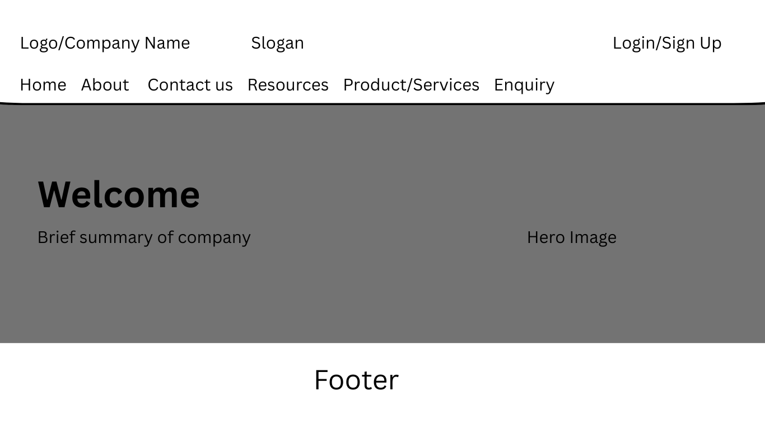
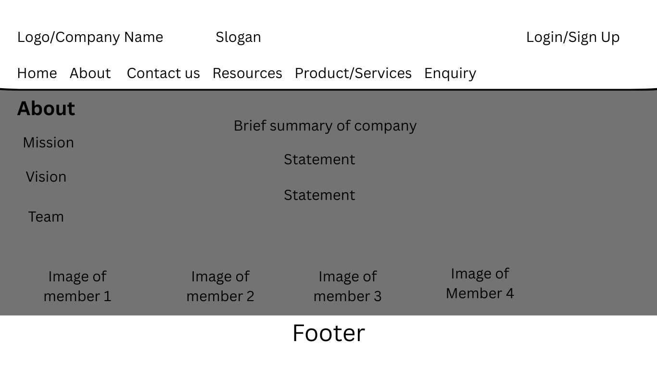
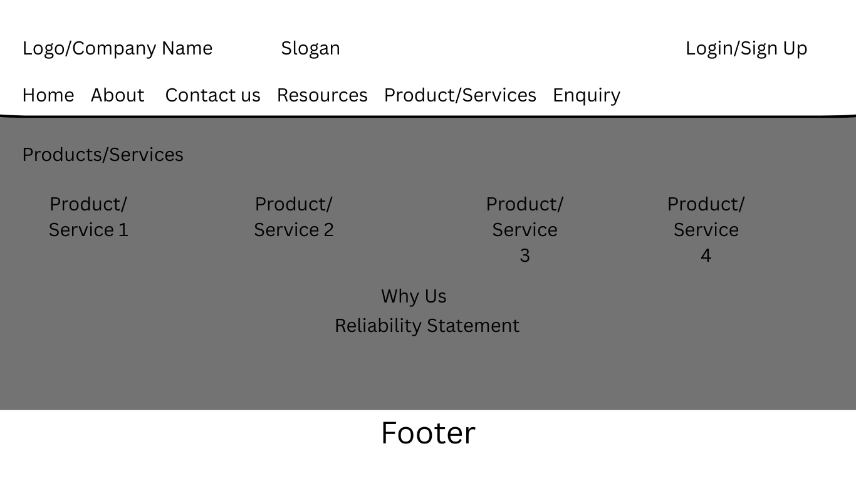
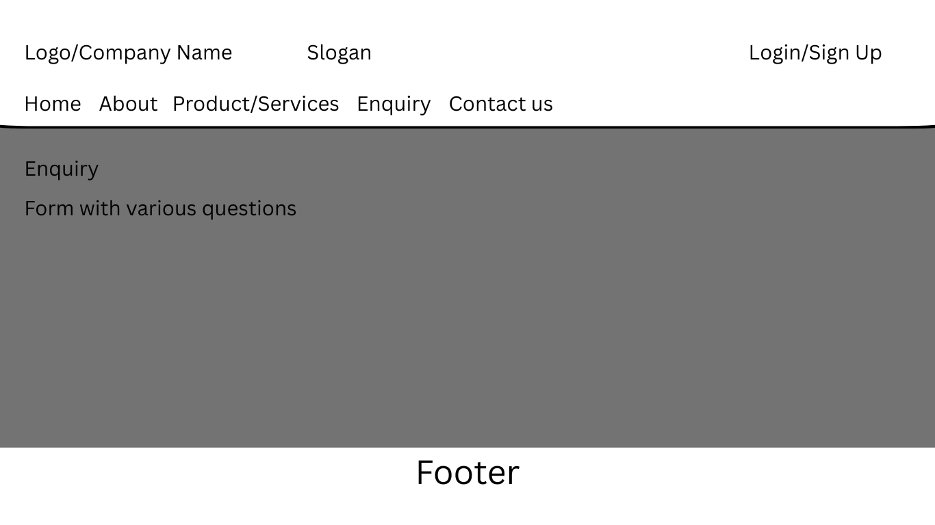
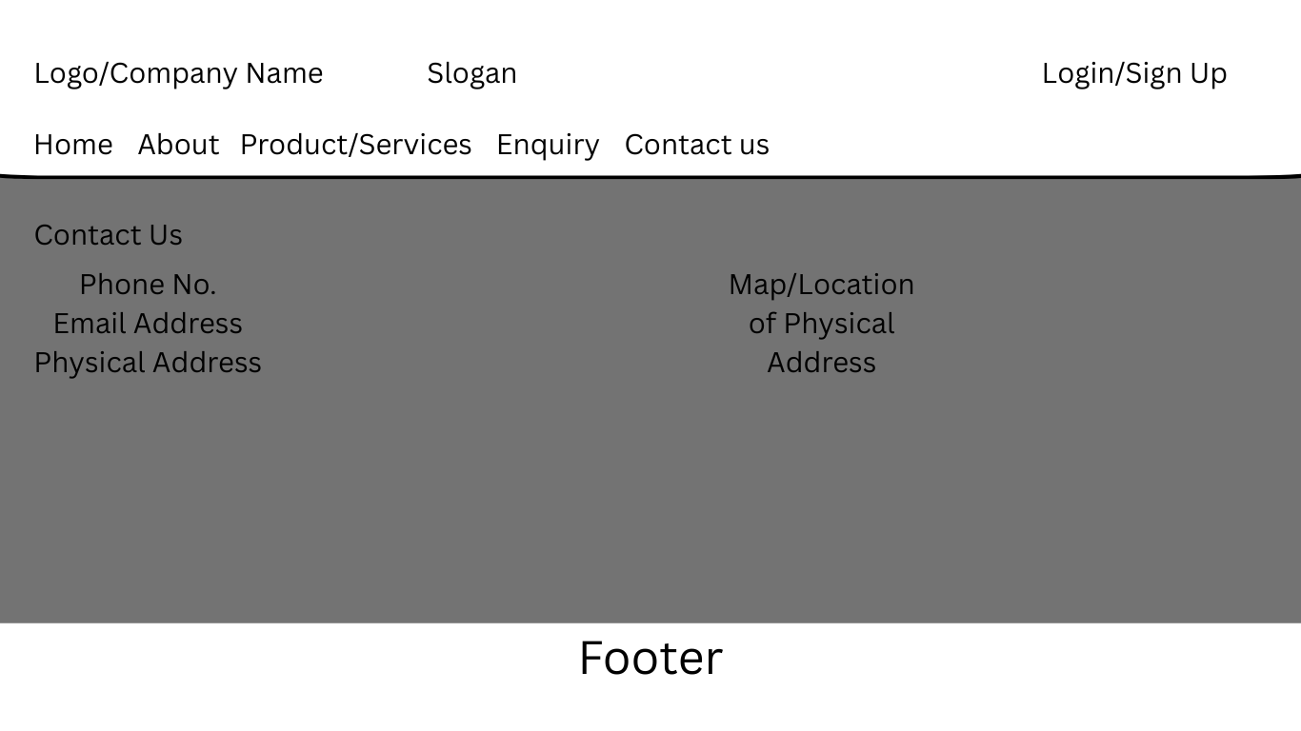

*Note All wireframes and colour pallet are also included in the image file

Technical requirements
1. Hosting
Requirements:
Since Bugcrowd is a big name in cyber security there are 2 hosting types that come to mind:
  - Dedicated Hosting: This type of hosting has full server resources for large websites
  - Cloud Hosting: This is a type of hosting that has scalable resources for fluctuating traffic.

When choosing the type of hosting these aspects must be kept in consideration:
- Storage and Bandwidth: Ensure the hosting plan offers sufficient storage and bandwidth based on expected traffic.
- SSL Certificate: For security, especially if handling sensitive data.
- Customer Support: 24/7 support is crucial for resolving issues quickly.
- Backup Solutions: Regular backups to prevent data loss.
(Quicksprout, n.d.)

2. Domain Name
Requirements:
- Domain Name: Choose a domain name that reflects your brand and is easy to remember.
- TLD (Top-Level Domain): Common options include .com, .org, .net, or country-specific TLDs.
- Availability: Check if the desired domain name is available and consider variations if necessary.
- Registration Period: Typically, domains are registered for one year but can be set for multiple years.
(Goldstein, 2023)
3. Programming Languages
Requirements:
- Frontend Development:
  - HTML: For structuring the content.
  - CSS: For styling the website.
  - JavaScript: For interactivity and dynamic content.

Budget
1. Domain Name: R180–R360/year
- A domain name (e.g., yourcompany.co.za) is essential for a professional online presence. The price depends on the domain registrar and any premium names you might want.
2. Web Hosting: R900–R3,600/year
- Shared hosting or entry-level cloud hosting is common for small businesses. The cost will vary based on traffic expectations and the hosting provider.
3. Website Design: R9,000–R54,000 (one-time)
- Template-based: If you're using a website builder or a pre-designed template (e.g. WordPress), the cost can be much lower, between R9,000 to R27,000.
- Custom Design: If you're looking for a custom-designed website, expect to pay R36,000–R54,000 or more for a professional designer.
4. Website Development: R18,000–R90,000 (one-time)
- Template Development: If you choose a template, there will be a cost for customization, ranging from R9,000–R27,000.
- Custom Development: If you need specific functionalities (e-commerce functionality), development costs can range from R36,000–R90,000 or more.
5. Content Management System (CMS): Free–R9,000 (one-time)
- Popular CMS options like WordPress, Wix, or Squarespace may come free or with a low subscription fee. For more complex CMS systems or premium plugins, there may be an additional cost.
6. SEO & Content Creation: R9,000–R45,000 (one-time)
- Basic SEO setup can range from R9,000–R18,000, but if you want ongoing SEO optimization and content creation (blogs, articles, product descriptions), costs could rise to R36,000–R45,000.
7. E-commerce Functionality: R9,000–R54,000 (one-time)
- For small online stores, adding e-commerce features (e.g., WooCommerce, Shopify) will increase costs. Basic setups are affordable, while more advanced e-commerce sites could cost between R27,000 and R54,000 depending on the number of products and customizations required.
8. Ongoing Maintenance: R9,000–R36,000/year
- Routine website maintenance, software updates, security patches, and backups are critical to keeping the site functioning well. You might choose to handle it yourself or hire a professional.
9. Marketing & Advertising: R9,000–R45,000/month (optional)
- Once your website is live, you may want to spend on digital marketing like Google Ads, social media campaigns, or other online advertising to attract traffic.
10. Additional Tools & Features: R1,800–R9,000/year
- Additional tools like email marketing services, form builders, or premium plugins (security, analytics, etc.) can add extra costs.

Total Estimated Cost Breakdown:
- Low-end (Template-based website): R27,000 – R72,000
- High-end (Custom design, complex functionality): R144,000 – R270,000+

Reference Page

- Bugcrowd, 2019. How it Works | Bugcrowd. [online] Available at: https://www.bugcrowd.com/products/how-it-works/

- Bugcrowd, n.d. About. [online] Available at: https://www.bugcrowd.com/about/

- Bugcrowd, 2022. Blog | Bugcrowd. [online] Available at: https://www.bugcrowd.com/blog/

- Bugcrowd, 2023. HP Launches Industry’s First Print Security Bug Bounty Program | Bugcrowd. [online] Available at: https://www.bugcrowd.com/press-release/hp-launches-industrys-first-print-security-bug-bounty-program/

- Goldstein, K., 2023. How to Register a Domain Name in 5 Steps (2024). [online] Wix Blog. Available at: https://www.wix.com/blog/how-to-register-a-domain-name

- McCracken, G., 2019. 2020 Vision: Cybersecurity Predictions for the Year and Beyond | @Bugcrowd. [online] Bugcrowd. Available at: https://live-bug-crowd.pantheonsite.io/blog/2020-vision-cybersecurity-predictions-for-the-year-and-beyond/

- MDN Web Docs. (n.d.). Document Object Model (DOM). [online] Available at: https://developer.mozilla.org/en-US/docs/Web/API/Document_Object_Model.

- Quicksprout, n.d. The 6 Best Types of Web Hosting to Consider in 2020. [online] Available at: https://www.quicksprout.com/types-of-web-hosting/

- W3Schools, n.d. CSS Rounded Corners. [online] www.w3schools.com. Available at: https://www.w3schools.com/css/css3_borders.asp

- W3Schools (2019). How To Create Tabs. [online] W3schools.com. Available at: https://www.w3schools.com/howto/howto_js_tabs.asp.

‌

